eSTAR-10 聽說紀錄表 Class: ____ Name: ________

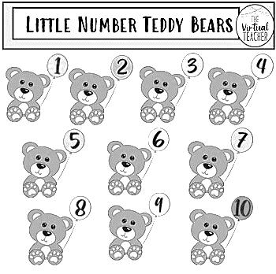

|  |  |  |  |  |  |
| --- | --- | --- | --- | --- | --- |
| Page頁碼 | CD No.光碟號碼 | 聽CD | 讀唸 | Parent’s signature家長簽章 | Remarks |
| Unit 3 | | 完成打勾✓ | | 請家長確認孩子完成並簽名 | |
| P.34**短文** | CD❶ No. 1-2 |  |  |  |  |
| P.35單字&片語 | CD❶ No. 3 |  |  |  |  |
| P.**36~37句型-1** | CD❶ No. 4 |  |  |  |  |
| P.**38~39句型-2** | CD❶ No. 5 |  |  |  |  |
| P. **40~41聽&讀** | CD❶ No. 6-8 |  |  |  |  |
| P. **42~43發音** | CD❶ No. 9-12 |  |  |  |  |
| P.44~46**故事** | CD❶ No. 13-14 |  |  |  |  |
| Unit 4 | | 完成打勾✓ | | 請家長確認孩子完成並簽名 | |
| P.48**短文** | CD❶ No. 19-20 |  |  |  |  |
| P.49**單字** | CD❶ No. 21 |  |  |  |  |
| P.**50~51句型-1** | CD❶ No. 22 |  |  |  |  |
| P.**52~53句型-2** | CD❶ No. 23 |  |  |  |  |
| P. **54~55聽&讀** | CD❶ No. 24-26 |  |  |  |  |
| P.56~57**發音** | CD❶ No. 27-30 |  |  |  |  |
| P.58~60**故事** | CD❶ No. 31-32 |  |  |  |  |
| Review 2 | | 完成打勾✓ | | 請家長確認孩子完成並簽名 | |
| P. 61-62 | CD❶ No. 37~38 |  |  |  |  |
| Fun Facts | | 完成打勾✓ | | 請家長確認孩子完成並簽名 | |
| P. 63-64 | CD❶ No. 39 |  |  |  |  |
| Final Exam期末考 | | 家長簽章數量: 個 | | | |